

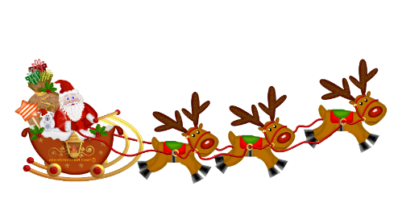
MANHOOD RIDING CLUB - CHRISTMAS SHOW 7th DECEMBER 2025
DRIVER & PASSENGER NAMES :___________________________________________________
CLASS NO | HORSE/PONY NAME | HEIGHT | HANDLERS NAME | ENTRY FEE
 |  |  | Donation to RDA (optional)
 |  |  | TOTAL


Entry before the day members £8 non members £10, classes on the day £15 (CASH ONLY)
BANK TRANSFERS TO - ACC NO: 49851586 SORT CODE: 60-05-24 PLEASE QUOTE YOUR NAME ON THE TRANSACTION
Please make cheques payable to ‘MANHOOD RIDING CLUB’ and send with completed form to –
Miss Heather Linfield, 92 Whichers Gate Road, Rowlands Castle, Hants, PO9 6BB
Telephone enquiries 02392 412550 after 7.00pm please

NAME (BLOCK CAPITALS): _________________________________________________________________________________________________________
ADDRESS:_______________________________________________________________________________________________________________________
_________________________________________________________________________________TELEPHONE NUMBER:____________________________
I agree to read & abide by the rules and take full responsibility for my actions and safety. I ENTER THIS SHOW KNOWING THERE IS NO FIRST AID ON SITE
SIGNATURE OF RIDER/LEADER:_____________________________________________________________________________________________________

