Manhood Riding Club Membership Form 2023/24
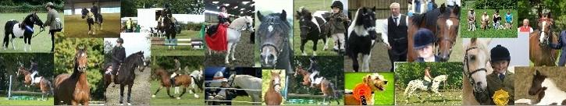
Subscriptions run from 1st October to 30th September

Email ______________________________________________________________________
Name ______________________________________________________________________
Address_____________________________________________________________________
____________________________________________Postcode________________________
Telephone____________________________________Mobile__________________________
Car/Lorry Registration__________________________________________________________

Signature___________________________________________Date_____________________
Members receive:
- A newsletter at least 4 times per year
- Members only events
- A wide selection of indoor/outdoor events and social activities
Membership Fees:
Adults: £10 Child (16 and under): £5

If you join after 31st December 2023 the membership will increase to Adult £20 and Child £10
Newsletters will only be emailed so please write your email clearly
Please make cheques payable to MANHOOD RIDING CLUB
Payment can also be made to the MRC Bank Account. Please ensure you reference the payment with your name.
Bank details are: Manhood Riding Club sort code 60-05-24 Account no 49851586
Completed membership forms and monies to be sent to or emailed to:
Mrs Jackie Brown, 11 Kingfisher Close, Rowlands Castle, Hants, PO9 6HG Jacqueline.brown456@hotmail.co.uk
*** All members are required to have public liability insurance for their horse/pony. You will need to confirm this before you can take part in our events and understand that any accident or injury caused by your horse/pony is your responsibility***

