Manhood Riding Club
Pat Starr Memorial Points Championship 2022/23
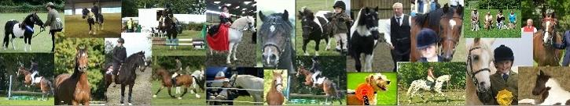
Points are awarded to Manhood members who have entered classes at any Manhood Riding Club show. Points are accumulated throughout the year, and in October the overall Championship trophies are awarded at the AGM to the Junior champion and Senior champion.
There are five categories that are eligible for the points – In-hand, Ridden, Jumping, Dressage and Rides. All entries will receive a rosette.
Please Note:
- Points will be awarded to one horse, one rider as a combination
- One horse/rider combination can be entered for free. £5 fee for any additional combinations
- We will not accept more than one horse/rider on form
- All results will be verified
Horse/Pony name: |  | Rider/Handler name:
Date of event | In-hand, Ridden, Jumping, Dressage or Rides (please specify) | Placings - 1st – 6th  Champion/Reserve etc. | Points awarded – committee use only

Completed forms MUST be returned by 1st September 2023 to Jackie Brown:
Email: Jacqueline.brown456@hotmail.co.uk
Address: 11 Kingfisher Close, Rowlands Castle, Hants, PO9 6HJ
No entries will be accepted after 1st September

